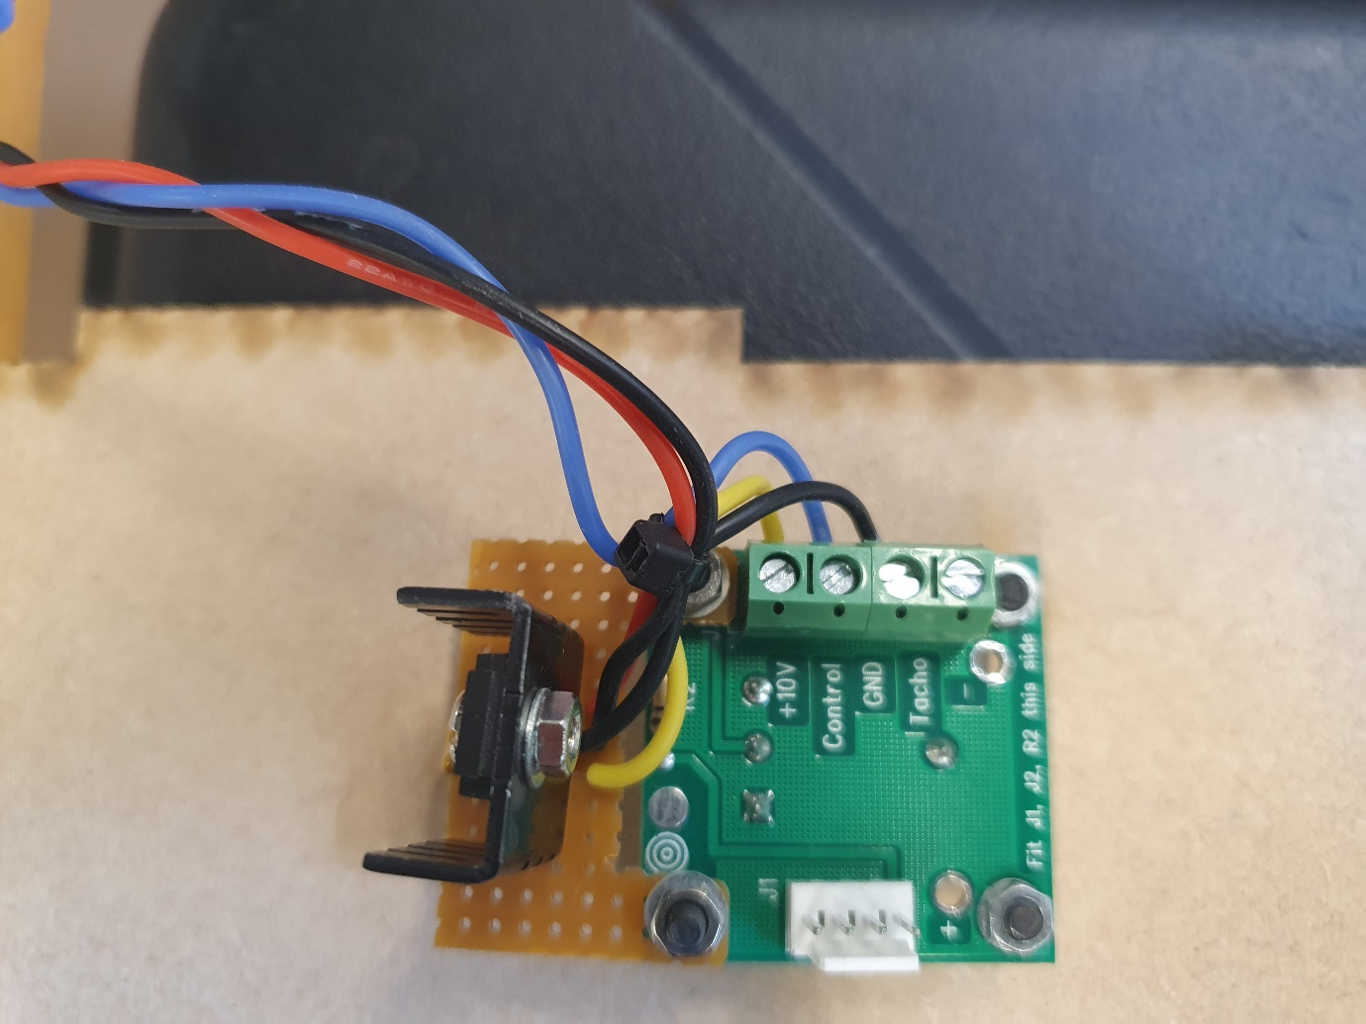

The speed is controlled using a10K potentiometer which is mounted on a PCB

The supply used is 10V from a 10V regulator, the heat sink is from CPC, order code 170072.

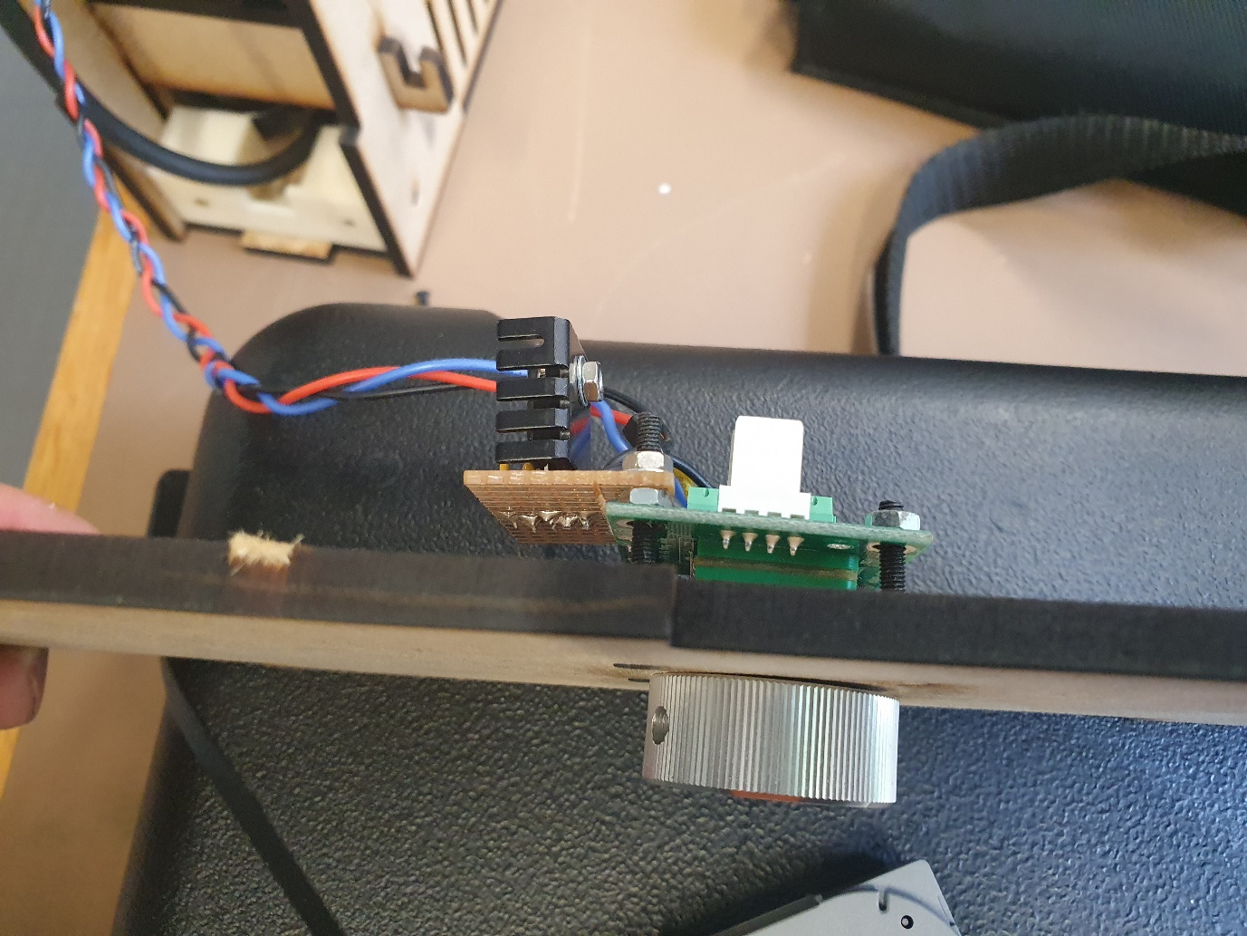

View from the top

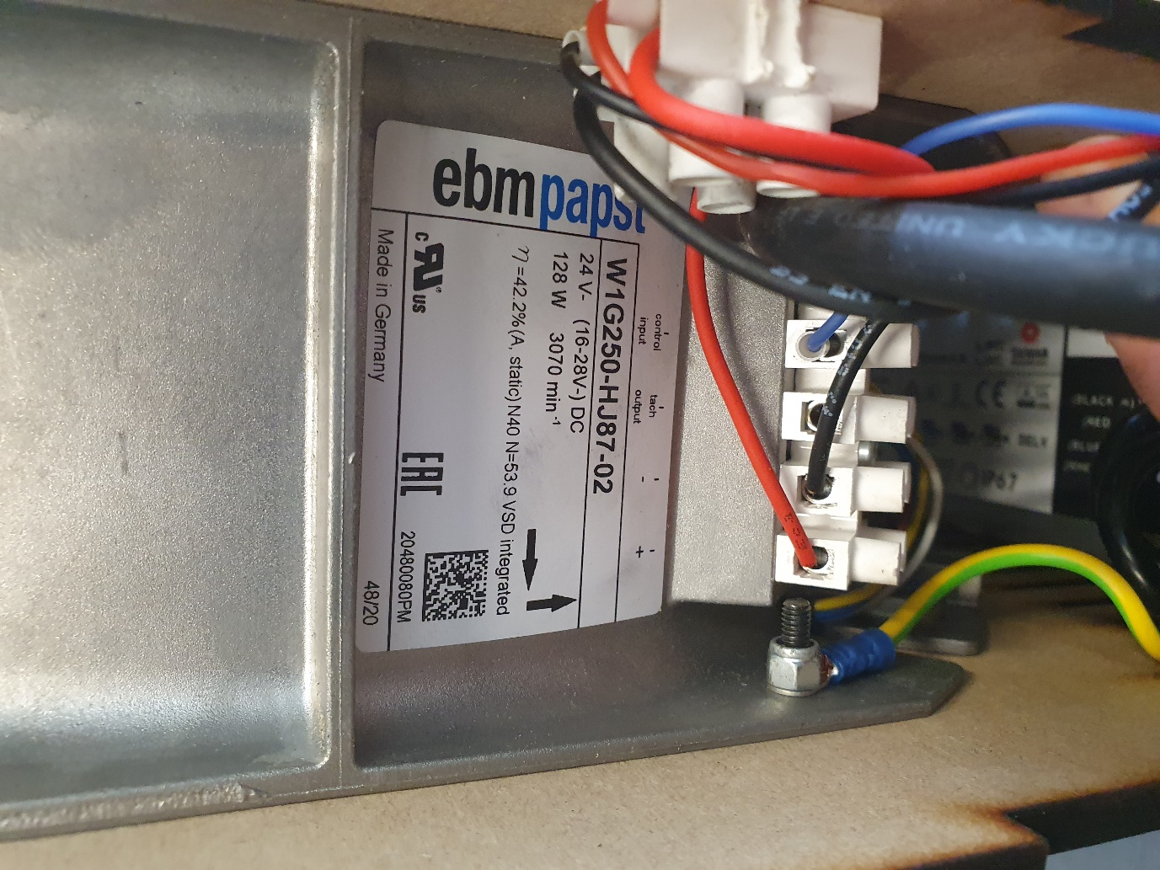

The Fan details, 24V coming in on red and black wires and the speed demand coming in on the blue wire.

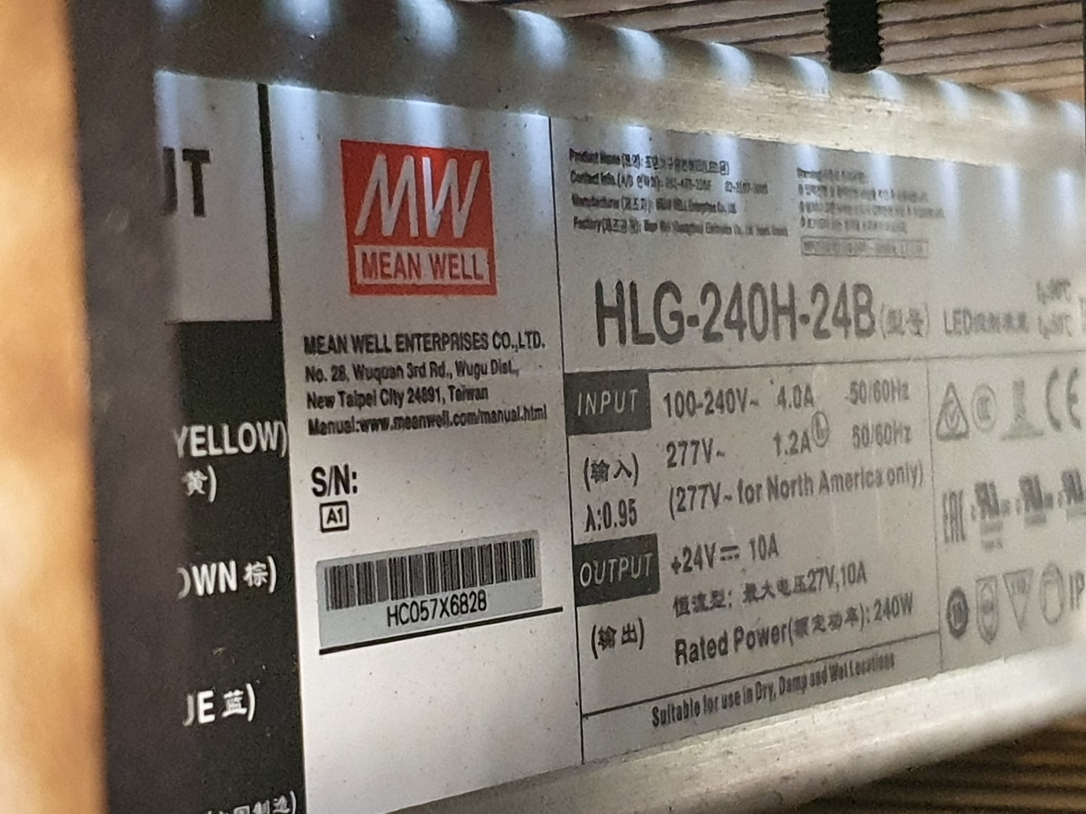

This is power supply for the Fan 24V.

So a simple setup with 0-10V demand for the speed from the 10K pot and a power supply to supply the Fan.